Canvas LMS User Task Analysis Summary
By: Alexandria Deleon, Yamini Kattelu, Gajendra Sharma, Shadericka Mills, Omar Alali

Introduction
Our project involved creating a fitness app called FitGoals and working on improving it using user testing strategies. When we were given the task of creating an app, we brainstormed different options until we decided on a fitness app. We wanted our fitness app to have the ability to track the user’s health progress, daily steps, water intake, calorie intake, and burned calories. After our prototype was designed, we allowed users to test it by guiding them through different tasks using scenarios we wrote. The results of our testing and data are shown in this document.

Demographics
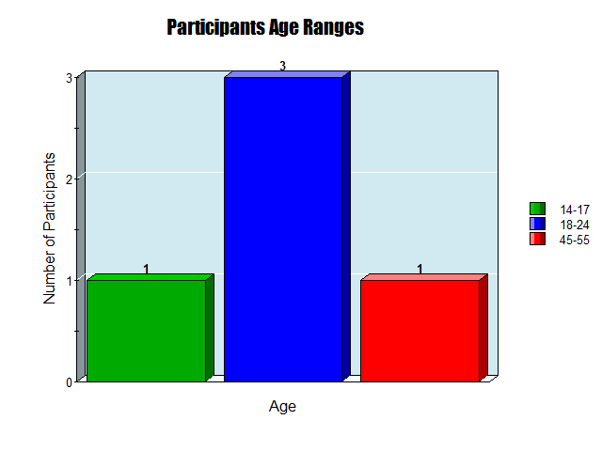
Out of the five participants, three were between the ages of 18-24.

- Out of the 5 participants, 4 were students and 1 was a part of the general public.

- 3 of the participants’ highest level of education was college while for the other 2 it was high school.

- 3 of the participants had 10 years of computer/web experience while 1 had 13 years and 1 had 15 years.

- 3 of the participants had intermediate computer level knowledge, 1 had beginner level knowledge, and 1 had experienced level knowledge.
- 3 of the participants were in the 18-24 age range, 1 was in the 14-17 age range, and 1 was in the 45-55 age range.

- 3 of the participants were male and 2 were female.

- All participants use the internet daily.

- All participants use the internet for activities such as email, entertainment, games etc. Email and entertainment were the most common.

Tasks/Scenario-like Goals

Task 1 Track their health progress

Task/Goal Verbiage: With your weight loss journey well underway, you and your brother seek additional motivation and support to stay on track. Your goal is to enhance your progress-tracking experience and keep you both motivated towards achieving your goal of losing 40 pounds each by June.

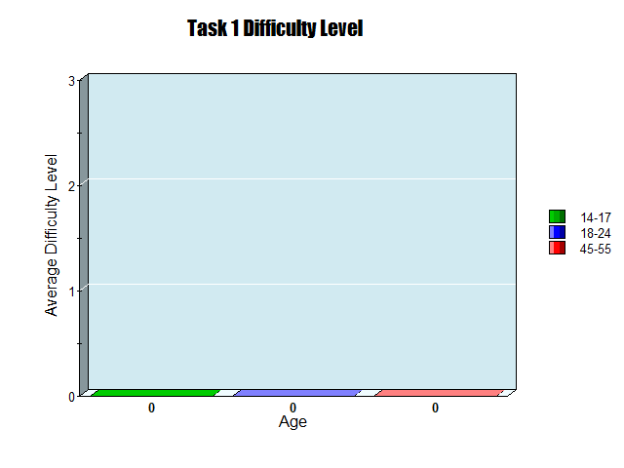
All the participants gave this feature a 0/3 in terms of ease of usability.

- Tracking health progress through the app was not difficult and looked consistent.
- Explaining how this part works and specifying the exercises to burn calories would improve the app function.
- Doesn't know if each day you can modify something in health goals.

le

Task 2 – Track their daily steps
Task/Goal Verbiage: A health-conscious athlete who makes an effort to include a variety of low-impact cardio activities in their fitness regimen and makes sure they reach a daily step count of 10,000 or more to support their physical fitness goals and overall health.

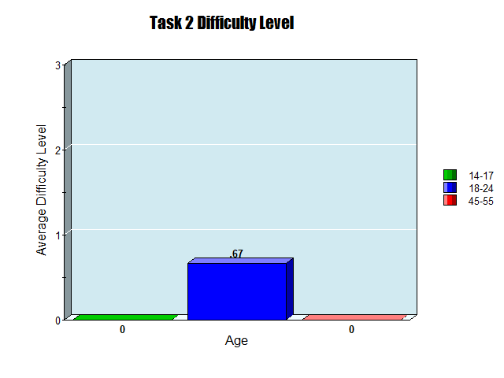
Even though most users found it simple there was a reoccurring question on if you had to manually track the steps.

- Four out of the five participants found this task easy to navigate, while one participant noted it should be able to include boxes to input information.
- It would make sense to be able to view each day’s data in Health Goals and modify the input for this part accordingly.

Task 3 – Reminder to drink water:

Task/Goal Verbiage: You are an inexperienced athlete who’s developed a bad habit of not drinking enough water every day. You want to set a reminder to drink 42 ounces of water at 8:00 a.m. and 12:00 p.m. How would you accomplish this?

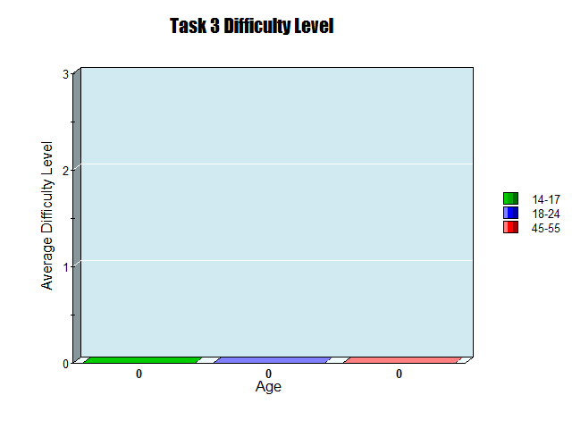
This task also received a 0/3 from all the participants making it one of the easiest to achieve.

- Most participants decided the part was efficient as it was easy to comprehend and included the features needed to track their daily water intake.
- Users appreciated the timer feature.

Task 4 – Track calorie intake:

Task/Goal Verbiage: You are a college athlete who is trying to gain weight and you find out that you need to eat more calories than you burn to gain muscle and weight. So, you use a calorie counter to make sure you eat 2800 calories per day. How would you accomplish this?

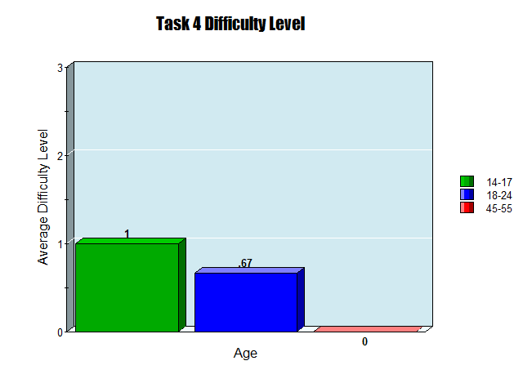
This task had a bit higher than average difficulty level compared to the other tasks. They had some issues with the calories burned feature.

- Three participants found the task slightly inconvenient to use as they would have to manually input everything.
- The app does its job of counting calories; however, it does not break them down into carbohydrates, protein, fats, etc.

Task 5 – Track Burned Calories:

Task/Goal Verbiage: Imagine you're a college athlete aiming to gain weight. To do this, you need to make sure you burn fewer calories than you consume. Here's how you can keep track:

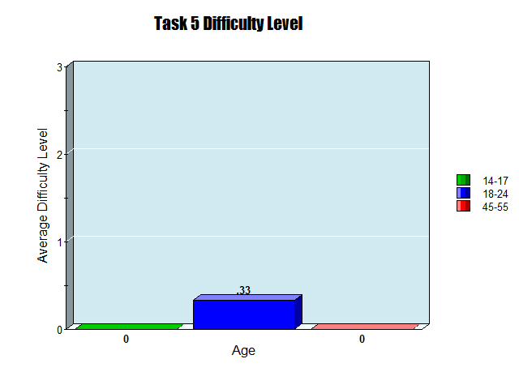
Average difficulty level for this task was low.
- You can log your hours of exercise in the app and track the number of calories you burn during your workouts.

- The user will have access to motivational content and can track the exact number of calories burned to stay motivated and on track with their fitness journey.

- The average difficulty was low

Overall Site Experience
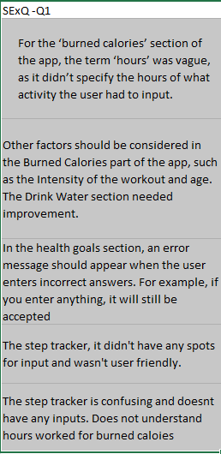
These are some of the features that users thought were vague or confusing.

- We received constructive feedback on the step tracker, burned calories, and health goals tabs.

- All the participants said the app was easy to use and they liked the colors.

- Participants wanted us to include recommended meal plans, more visuals, name input, exercise techniques, and daily reminders.

- Participants liked how easy the app was to navigate and does what it was made for.

- Participants did not like how you are not able to set different logs for each day, the inconsistent button sizes, the use of kgs, and inconsistent fonts.

- Participants all stated that nobody will have a problem using the app.

- None of the participants had any additional comments.

Conclusions & Recommendations

Conclusions
- Overall, the site was easy to navigate, and the colors were “calming”
- Tasks 1,2, and 5 seemed to be the ones that the users had the most trouble with. The health goals section should include an error message for incorrect answers. The steps tracker needed inputs and wasn't very user friendly. Lastly the burned calories section was too vague for the participants and needed more to it.

Recommendations
- Recommended meal plans for the users that might want to lose weight or enhance their diet.
- Include some exercises or techniques that could be helpful depending on the tab you open.
- More visuals overall, and uniformity between each section.

